

Table of Contents
1. Purpose 2
2. Basis for the 2027 Audit Plan 2
3. NC Register Analysis – Priority Areas 3
4. Why the 2027 Plan Has Been Changed 4
5. 2027 Internal Audit Schedule – January to December 5
6. Coverage of ISO/IEC 17025:2017 Clauses 7
7. Additional Risk-Based Audit Controls for 2027 8
8. Expected Audit Outputs and Records 8
9. Closing statement and context for the 2027 internal audit programme. 9
10. Review and Approval 10
11. Revision Table 10

INTERNAL AUDIT PLAN -2027
ISO/IEC 17025:2017 – Risk and NC Based Internal Audit Program
Document no. | AUI001 | Effective date | 01/2027
Revision status | 01 | Next review date | 11/2027
Audit period | January – December 2027 | Standard | ISO/IEC 17025:2017
Compiled by | Laboratory Manager | Approved by | Operations Manager

1. Purpose
The purpose of this Internal Audit Plan is to establish a complete January–December 2027 programme for evaluating the laboratory’s conformity with ISO/IEC 17025:2017, its own management system, applicable customer/regulatory requirements and the effectiveness of actions arising from previous non-conformities (NCs). The programme is deliberately risk and evidence-based: recurring NC areas receive greater audit attention, while every ISO/IEC 17025 clause within Clauses 4–8 is addressed during the year.

2. Basis for the 2027 Audit Plan
The 2027 programme was developed using the 2026 Internal Audit Plan together with the NC Register. The 2026 plan was structured around general requirements, resources, processes and the management system, with additional monthly audits from July to December. It scheduled separate reviews of documentation, personnel, facilities/equipment, testing and validation, customer-related activities, and risk/corrective action/management review. This provided useful coverage, but the NC Register demonstrates that some areas require more deliberate and repeated verification than a single annual audit.
The 2027 plan therefore changes from a largely topic-based schedule to a risk-based programme in which:
(1) all ISO/IEC 17025 Clauses 4–8 are mapped into the annual programme;
(2) recurring NC clauses are prioritised;
(3) high-risk process areas are audited before or alongside related supporting-system controls;
(4) follow-up/effectiveness verification is built into the programme rather than treated only as an end-of-year activity;
(5) The internal audit process itself is audited as a high-risk management-system process.

3. NC Register Analysis – Priority Areas
The NC Register contains 50 entries explicitly referenced to ISO/IEC 17025 among the internal and external findings reviewed. The following frequency analysis is based on the clause references recorded in the register. Where a finding references more than one clause, the relevant clauses are treated as separate coverage points. ISO 17034, ISO 17043 and ISO 13528-only references were not used to inflate the ISO/IEC 17025 frequency ranking.
ISO 17025 area | NC frequency / basis | 2027 priority | Reason for emphasis
8.8 / 8.8.2 - Internal audits | 8+ recorded references | Very high | Repeated weaknesses in audit planning, criteria, reporting, records, meetings, auditor competence/impartiality and scheduling.
7.7 - Validity of results | 4 | High | Repeated control-chart/action, PT-plan and control-result issues; validity monitoring requires stronger routine verification.
7.2 - Selection, verification & validation of methods | 4 when 7.2 subclauses are included | High | Method execution, validation and method-document control findings, including total moisture and inherent moisture.
7.10 - Nonconforming work | 3 | High | NC handling, records, dates, responsibility and LIMS/reporting-related nonconforming outputs require verification.
6.6 – Externally provided products/services | 3+ | High | Supplier/service-provider evaluation and approval, including outsourced testing, were identified as weaknesses.
6.4 - Equipment | 2 | High | Equipment control, verification ranges and supporting procedures/records were found deficient.
8.7 - Corrective action | 4 when 8.7/8.7.1 are combined | High | Risk assessment, timelines, effectiveness verification and prevention of recurrence were repeatedly identified.
4.1 - Impartiality | 4 | High | Declarations, risk evaluation, financial dependence and audit impartiality were identified as weaknesses.
5.3 / 5.4 - Structure and activities | 3 | Moderate-High | Scope/activities and applicable requirements needed clearer definition and documentation.
8.3 - Control of management-system documents | 2 | Moderate-High | Obsolete/revised versions and change identification were identified during external assessment.
8.9 - Management review | 2 | Moderate | Required inputs, actions, responsibilities and due dates needed stronger evidence.
Note: The frequencies above are based on the clause references as entered in the NC Register. They should be used as an audit-risk indicator rather than as a statistical measure of laboratory performance.

4. Why the 2027 Plan Has Been Changed
- 1. Recurring technical-process findings: The NC Register shows repeated findings under 7.2 and 7.7. These are core technical controls and can directly affect confidence in reported results. The 2027 programme therefore separates method controls and validity-of-results controls into dedicated audit activity and requires sampling of actual records/results.
- 2. Internal audit process became a significant risk area: Multiple findings were recorded against 8.8/8.8.2, including audit planning, criteria, reporting to management, opening/closing meetings, auditor records/signatures, availability of records, scheduling and auditor competence/impartiality. The 2027 plan therefore audits the internal-audit process itself and requires documented follow-up.
- 3. Corrective-action effectiveness needs stronger verification: Findings under 8.7/8.7.1 identified weaknesses around NC timelines, risk assessment and effectiveness verification. The new programme incorporates follow-up reviews of significant NCs rather than relying only on closure status.
- 4. Equipment and external-service controls require closer monitoring: Findings under 6.4 and 6.6 included verification range, equipment control, supplier/service-provider evaluation and outsourcing approval. These controls are placed earlier in the year and are linked to technical-process audits.
- 5. Impartiality and structural controls need routine verification: Findings under 4.1 and 5.3/5.4 demonstrate that impartiality risks, declarations, scope/activities and applicable requirements need periodic confirmation, not only document review.
- 6. The 2026 programme was not fully achieved as scheduled: The NC Register records that an internal audit planned for August 2026 was not conducted as scheduled. The 2027 plan therefore assigns defined monthly audit outputs and includes management monitoring of completion.
- 7. Full-year coverage is required: The 2026 plan commenced in May and concentrated the programme into May–December. The 2027 plan runs January–December, allowing the laboratory to audit, correct, follow up and re-audit during the same calendar year.
- 8. Management system maturity: The register includes findings associated with documentation, records, management review, feedback, risk, corrective action and internal audits. The 2027 programme therefore treats the QMS as an integrated system rather than auditing documents independently from their implementation.

5. 2027 Internal Audit Schedule – January to December
Each monthly audit is intended to verify both documented arrangements and implementation. Audit sampling should include records generated during the period, interviews, direct observation where applicable, and traceability from requirement → procedure → record → result. High-priority areas may receive additional spot checks during subsequent audits.
Month | Audit focus | ISO 17025 clauses | Scope / key activities | Priority basis | Primary outputs
January | General requirements & impartiality | 4.1–4.2 | Impartiality risks and controls; declarations/conflicts; financial and organisational threats; confidentiality arrangements; management responsibilities; evidence that impartiality controls are implemented and communicated. | High – repeated 4.1 findings | Audit report, risk/declaration samples, interview records
February | Structural requirements & scope | 5.1–5.7 | Legal/organisational identity; management structure; laboratory activities and scope; applicable standards/customer/regulatory requirements; roles, responsibilities, authority, resources and communication. | Moderate–High – 5.3/5.4 findings | Scope review, organisation/role records, requirements register
March | Personnel & competence | 6.1–6.2 | Personnel competence, authorisation, supervision, training, competency evaluation, records, technical responsibility and impartiality of personnel performing laboratory work. | Preventive emphasis; linked to 8.8 auditor competence issue | Competence records, training/evaluation evidence
April | Facilities, environmental conditions & equipment | 6.3–6.4 | Suitability of facilities; environmental monitoring; equipment identification, use, maintenance, verification, calibration, intermediate checks, records and equipment status. Include crusher, pulveriser, balances, ovens and related laboratory equipment. | High – 6.4 findings | Equipment checklist, maintenance/verification records
May | Metrological traceability & externally provided products/services | 6.5–6.6 | Traceability of measurements; calibration/reference standards; CRM use; supplier/service-provider selection, approval, monitoring and re-evaluation; outsourced testing controls and records. | High – 6.6 findings | Traceability records, supplier evaluations, outsourced-service records
June | Review of requests, tenders, contracts & methods | 7.1–7.2 | Contract/request review; capability and resources; method selection; current methods; method verification/validation; performance characteristics; method changes; technical procedures and effective document status. | High – repeated 7.2 findings | Contract-review samples, methods, validation/verification records
July | Sampling, handling & technical records | 7.3–7.5 | Sampling where applicable; sample identification, transport, receipt, storage and handling; technical records; observations/calculations; traceability of amendments and retention of records. | High process-control emphasis | Sample records, worksheets, technical records
August | Measurement uncertainty & validity of results | 7.6–7.7 | Identification of uncertainty contributors; evaluation/estimation; control samples; control charts; PT/ILC participation; trend/bias investigation; acceptance criteria; actions when results are outside criteria. | Very high – 7.7 recurrence and 7.6 finding | Uncertainty budgets, control charts, PT plan/results, investigations
September | Reporting of results & data/information management | 7.8 & 7.11 | Report content and authorisation; amendments; statements of conformity where applicable; data transfer; LIMS controls; calculations; automated exports; data integrity, access and protection. | High – 7.10/7.11/LIMS-related finding | Report samples, LIMS checks, data-verification records
October | Complaints & nonconforming work | 7.9–7.10 | Complaint availability and handling; investigation and decisions; control of nonconforming work; responsibilities for resumption; NC records; impact assessment; communication and reporting. | High – 7.10 findings | Complaint register, NC register, case files
November | Management system documentation, records, risks & improvement | 8.1–8.6 | Management-system option and structure; policies/objectives; document control; record control; risk/opportunity actions; improvement; feedback; evidence of changes and effectiveness. | High – 8.3 and system-control findings | Controlled-document register, records, risk register, feedback/improvement records
December | Corrective action, internal audits & management review | 8.7–8.9 | NC correction/cause analysis; risk evaluation; corrective-action effectiveness; recurrence; internal-audit programme, criteria, competence, independence, reporting and records; management-review inputs, outputs, actions and follow-up. Include 2027 audit programme completion and 2028 inputs. | Very high – 8.7/8.8/8.9 concentration | CAPA records, audit files, management-review pack, annual audit summary

6. Coverage of ISO/IEC 17025:2017 Clauses
Clause range | Scheduled month | Coverage
4.1–4.2 | January | Impartiality and confidentiality
5.1–5.7 | February | Structure, scope, activities, roles, authority and communication
6.1–6.2 | March | Resources and personnel
6.3–6.4 | April | Facilities, environmental conditions and equipment
6.5–6.6 | May | Metrological traceability and externally provided products/services
7.1–7.2 | June | Contract review and methods
7.3–7.5 | July | Sampling, handling and technical records
7.6–7.7 | August | Uncertainty and validity of results
7.8 & 7.11 | September | Reporting and data/information management
7.9–7.10 | October | Complaints and nonconforming work
8.1–8.6 | November | Management-system requirements, documents, records, risk and improvement
8.7–8.9 | December | Corrective action, internal audits and management review

7. Additional Risk-Based Audit Controls for 2027
- NC follow-up sampling: Open or recently closed major NCs shall be sampled during the first applicable audit after closure, with effectiveness checked against objective evidence rather than closure status alone.
- Repeat finding escalation: Where the same clause or process is found deficient again, the audit shall consider whether the root cause, corrective action or implementation was inadequate and whether management-system changes are required.
- Unannounced/spot verification: For high-risk technical controls such as equipment checks, control charts, sample handling and LIMS/report transfer, the lead auditor may perform short spot checks between scheduled audits.
- Audit completion monitoring: The status of each planned audit shall be tracked monthly. Any postponed audit shall have a documented reason, revised date and approval. This directly addresses the 2026 missed-audit finding.
- Auditor competence and impartiality: Auditors shall be selected based on demonstrated competence and shall not audit activities for which their independence is compromised. Competence evidence shall be retained.
- Evidence-based reporting: Each audit report shall identify criteria, scope, objective evidence, findings, responsible persons, due dates and follow-up requirements. Records shall be retained in the required formats and locations.
- Management review linkage: The annual audit programme, audit results, recurring findings, overdue actions and effectiveness trends shall be used as inputs to management review and the establishment of the following year's audit programme.

8. Expected Audit Outputs and Records
- Approved annual internal audit plan and any approved amendments.
- Audit scope/criteria and audit programme for each monthly audit.
- Audit checklists or working papers demonstrating objective evidence.
- Interview and observation records where applicable.
- Audit reports identifying conformity, non-conformity, observations and opportunities for improvement where used by the QMS.
- Corrective-action / CAPA records, including root cause, action, responsibility, due date and effectiveness verification.
- Evidence of follow-up and closure of previous findings.
- Annual summary showing completion of the audit programme, recurring NC trends and recommendations for the 2028 audit programme.
- Management-review evidence demonstrating consideration of audit results and system performance.

9. Closing statement and context for the 2027 internal audit programme.
- The nonconformities identified during the review period should be considered within the context of the laboratory's accreditation development and implementation of its management system. A number of the nonconformities recorded in the NC Register originated from the SANAS document review process, while others were identified during the SANAS site visit. At the time, the laboratory was continuing to develop, implement and refine its management system and associated processes in preparation for, and during, the accreditation process.
- The identification of nonconformities should therefore not, in isolation, be interpreted as evidence that the laboratory's Quality Management System (QMS) was fundamentally ineffective or in a state of disorganisation. The laboratory addressed the identified nonconformities through corrective actions, and follow-up activities were conducted to verify the implementation and effectiveness of those actions. Where corrective actions were evaluated, they were found to be effective. The laboratory subsequently achieved SANAS accreditation, providing further evidence that the identified issues were addressed sufficiently for the applicable accreditation requirements.
- The purpose of the 2027 Internal Audit Programme is consequently not to respond to an assumption that the QMS is in a state of failure. Rather, the programme is intended to maintain the integrity, effectiveness and sustainability of the established management system and to prevent deterioration of controls over time.
- The NC Register has nevertheless been used as an important input into the development of the 2027 programme. Recurring or significant areas of nonconformity have been given increased audit attention so that the laboratory can confirm that corrective actions remain effective, that improvements have been sustained, and that similar issues do not recur. This approach is consistent with maintaining a risk-based internal audit programme in which previous findings, changes within the laboratory, operational experience and the importance of individual processes are considered when determining audit priorities.
- The 2027 programme therefore serves two complementary purposes:
- To verify continued conformity of the laboratory's activities and management system with the requirements of ISO/IEC 17025:2017; and
- To safeguard the continued effectiveness of the QMS by identifying emerging weaknesses, monitoring previously identified areas of risk, and ensuring that established controls remain implemented and effective.
- Accordingly, the increased audit attention given to certain clauses should not be interpreted as an indication that those areas are currently nonconforming. Rather, the increased frequency or depth of auditing reflects the laboratory's previous experience, the potential consequences of failure in those areas, and the need to maintain confidence in the effectiveness of the system.
- The overall objective of the 2027 Internal Audit Programme is therefore to ensure that the QMS remains intact, implemented, effective and continually maintained, and that the laboratory continues to meet the applicable requirements of ISO/IEC 17025:2017 throughout the accreditation cycle.

10. Review and Approval
This plan shall be reviewed before implementation and whenever significant changes occur to the laboratory's scope, organisation, personnel, methods, equipment, customer/regulatory requirements, accreditation status or risk profile. Changes to the approved programme shall be documented with the reason for the change and approved by the designated management authority.

Compiled by | 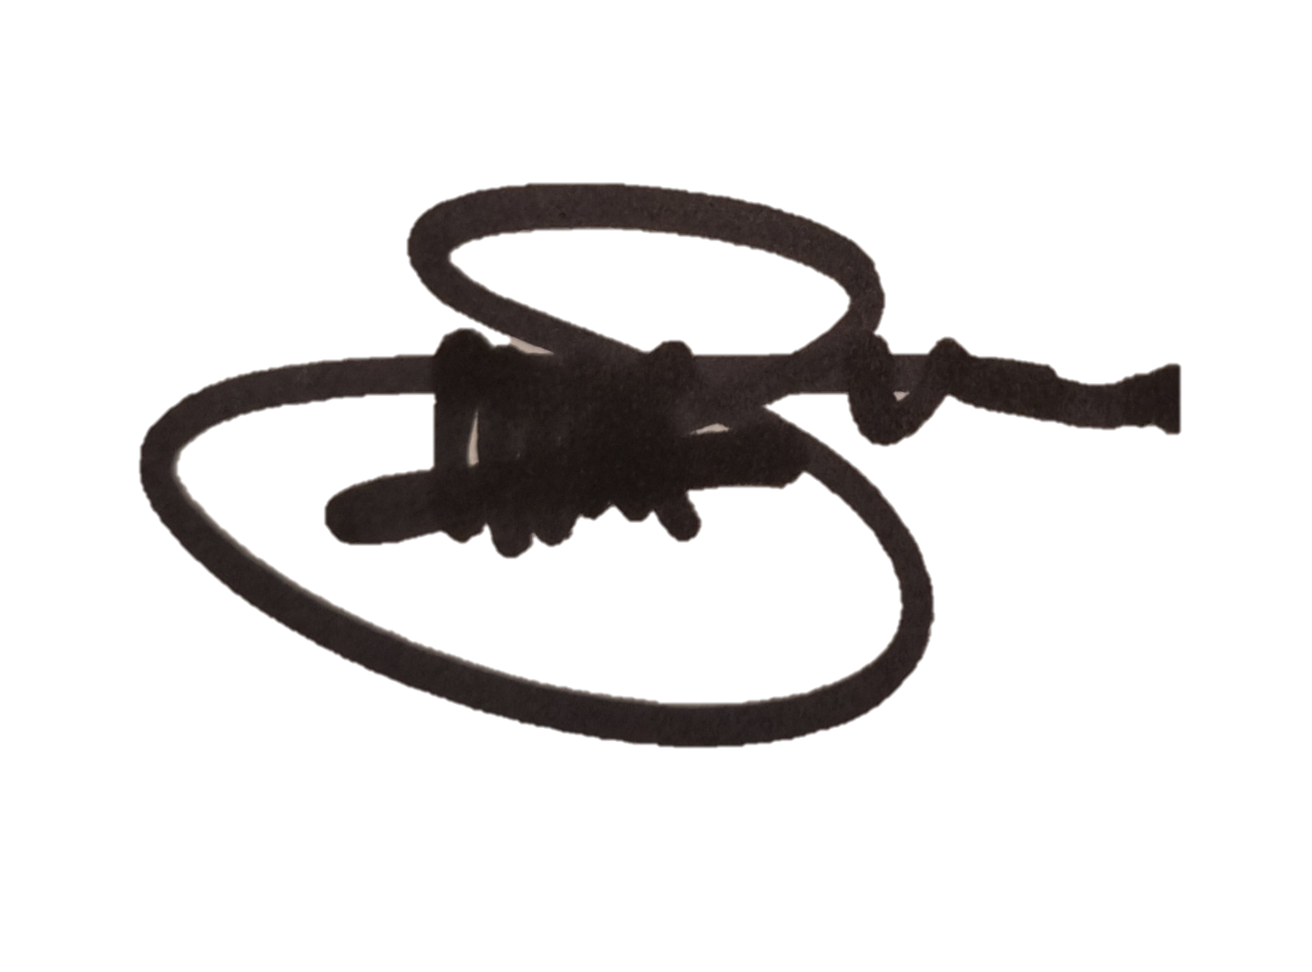 | Date | 30/09/2026
Reviewed by |  | Date
Approved by |  | Date

11. Revision Table

Changed content | Reason for the change | Person responsible | Revision no

